How to obtain Solar Radiation Data for international locations.

1. User will need to create a signon to the NASA website
Connect to the following URL:
http://eosweb.larc.nasa.gov/cgi-bin/sse/register.cgi

You will be prompted with the following screen. Input an Email Address and your password two times. The second time is for new users only.

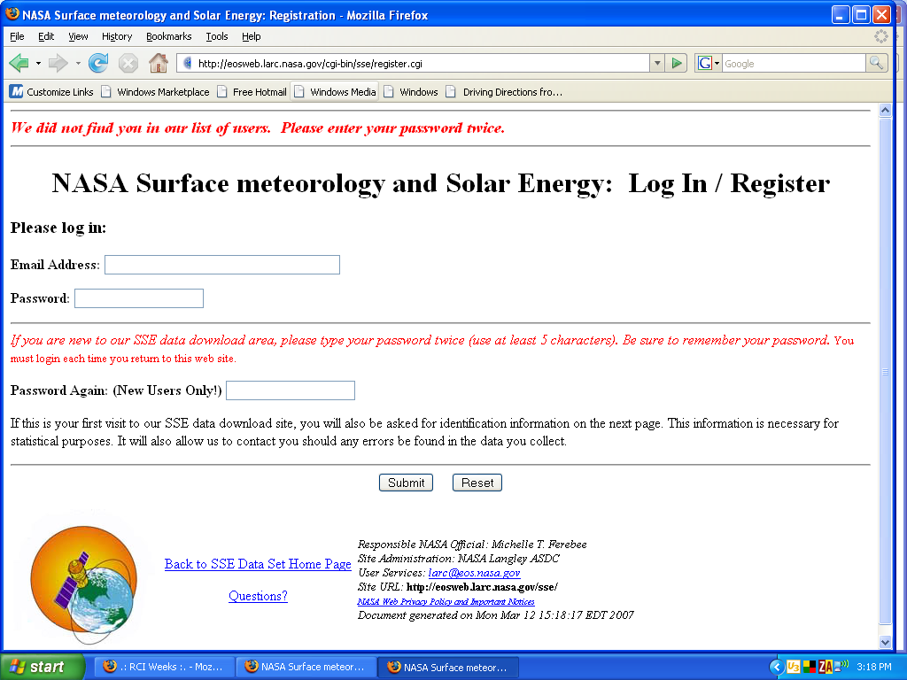

Click Submit

The next screen you see will be:

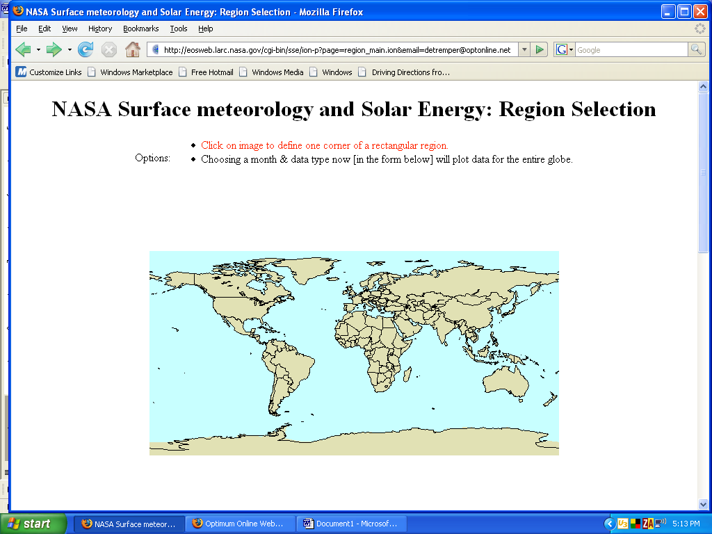

You will scroll down to the bottom of the screen and click on:

2. Back to SSE Data Set Home Page

The next screen to appear is:

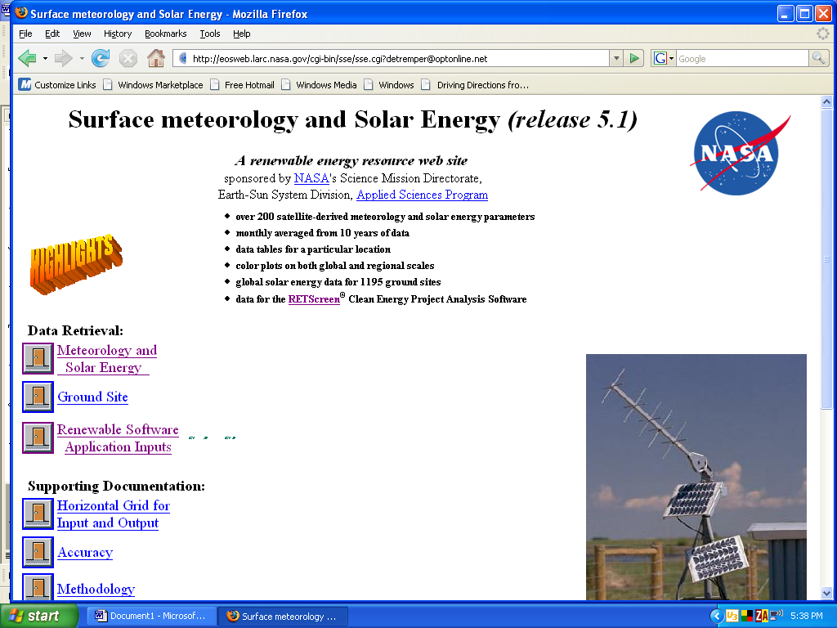

On the left hand side under Data Retrieval click:

3. Meteorology and
Solar Energy

The fourth screen to appear is:

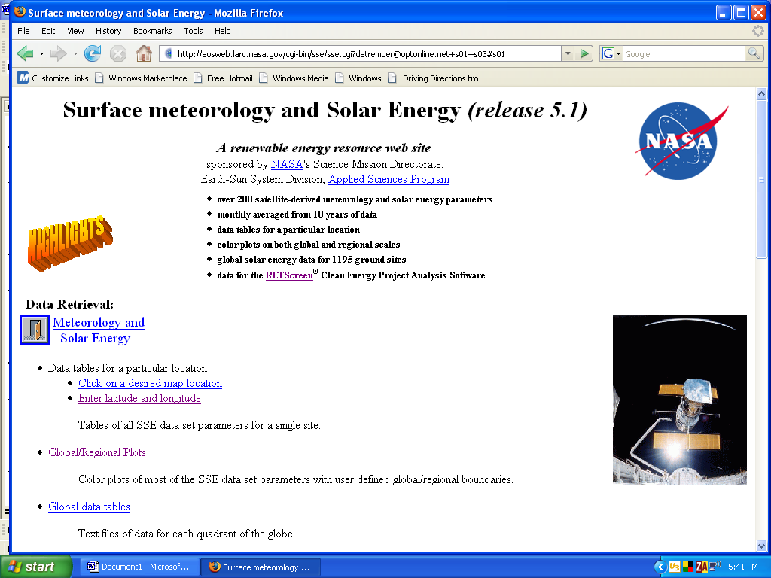

4. Select “Enter a latitude and longitude”. The following screen will appear:

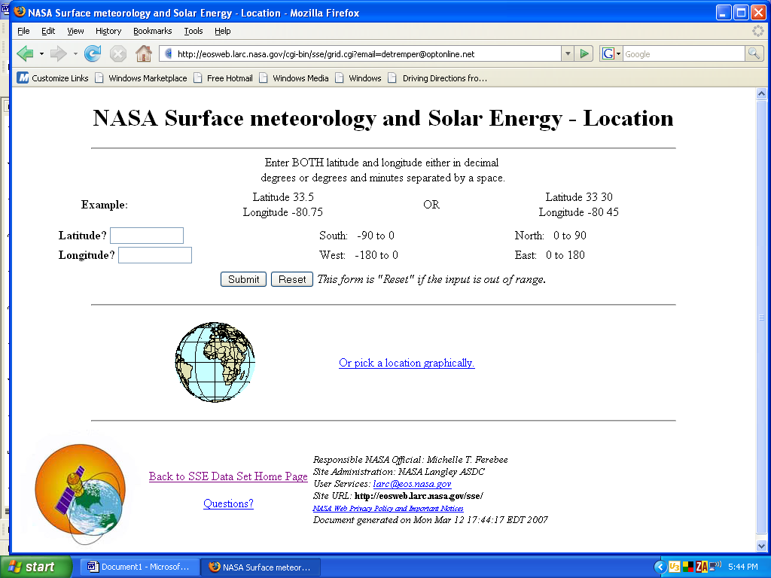

5. Fill in the latitude and longitude and select submit.

The following screen appears:
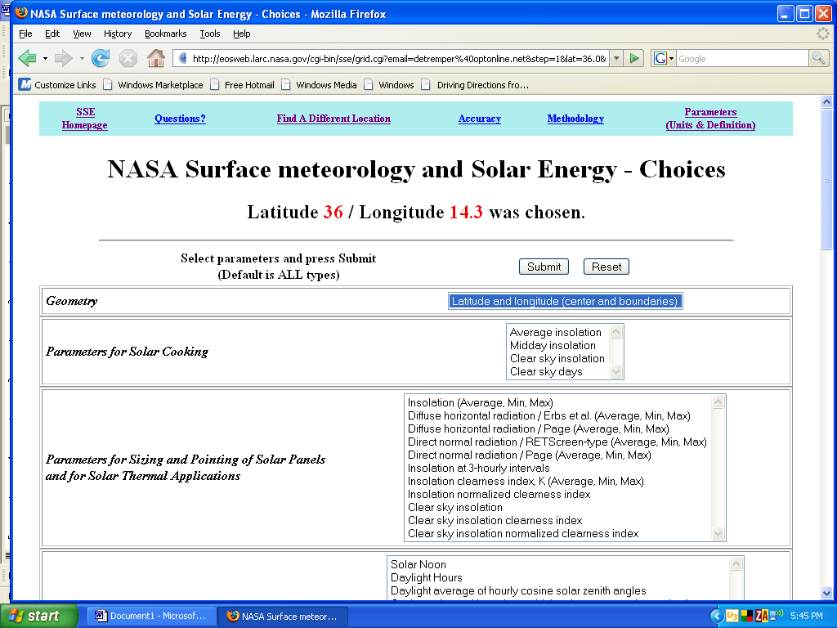

In the previous case a latitude of 36 degrees 0 minutes North was chosen. The longitude was 14 degrees 18 minutes East.

5. Notice in the second box the many different choices of data to retrieve. Select the first choice of Insolation (Average, Min, Max) and “submit” if you want

Insolation on horizontal surface (kWh/m²/day)
Amount of electromagnetic energy (solar radiation) incident on the surface of the earth. Also referred to as total or global solar radiation. The average and percent difference minimum and maximum are given.

Then the data values will appear.

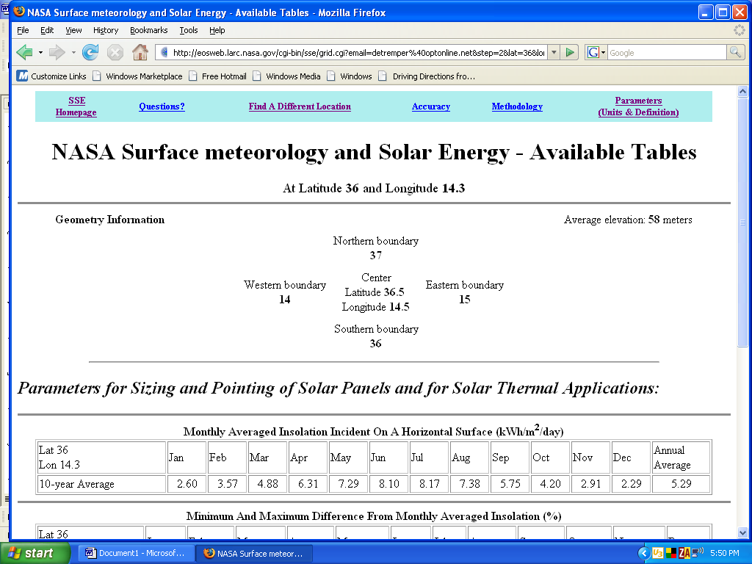

Note that version 2.0 of the SolarPathFinder Assistant will be incorporating the tables for this data from NASA.

In the interim, this How To Doc has been provided to those who will be using the SolarPathFinder outside of North America.

Acknowledgement:
These data were provided by the Prediction of Worldwide Energy Resource
Project and were obtained from the NASA Langley Research Center Atmospheric
Sciences Data Center.

Transpose Data to Vertical Format in Excel:
If user desires they can copy and paste the data values into an excel spreadsheet. In order to transpose the data follow these steps:

- Copy the rows you wish to change from horizontal to vertical columns.
- Select a cell below that is clear. Right click and “Paste Special”.
- On next pop-up menu select “Transpose” and click OK.
- Then manually move the titles if desired.
- Finally delete the horizontal data.

